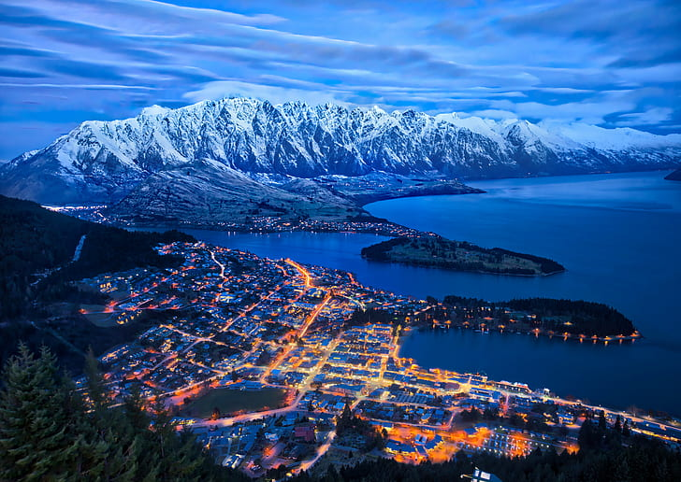0

Requirements

Document

Project: Website Upgrade

Organisation: Luxury Resort Queenstown

Author: Germaine Matenga

Table of Contents

**Stakeholders 2**

**Executive Summary 3**

**Current State: 3**

**The Problem: 3**

**Our Solution: 3**

**Assumptions 4**

**Business Requirements 5**

**User Requirements 6**

**Functional Requirements 8**

**Non-Functional Requirements 10**

**Scope and Constraints 11**

**Scope: 11**

**Constraints: 11**

**Charts and Diagrams 12**

**Terms of Reference** Error! Bookmark not defined.

# Stakeholders

|  |  |  |  |
| --- | --- | --- | --- |
| Name | Functional Role | Description | Requirements Role |
| Germaine Matenga | Business Analyst | Germaine Matenga has been working as a business analyst for 15 years. He is the project manager and will be working closely with the Stakeholders during this project | Author |
| Mathew McKelvie | Project Sponsor | Matthew McKelvie is a co-owner /of LRQ and the Project Sponsor. He is an expert in Database Management Systems. He will be providing information on features to help build the website. | Approver |
| Jane McKelvie | Project Advocate | Jane McKelvie is a co-owner of LRQ.  She has excellent market researching skills and has invaluable insight into the hotel market. | Reviewer |
| Patrick Parata | Project Advocate | Patrick Parata has expertise in accelerating a world-class resort loyalty programme. He speaks 5 languages and has a rich understanding of Maori culture. | Reviewer |
| Patrick’s Team | Project Advocate | Patrick’s team of consultants work under him and share his same passion about customer experience. | Reviewer |
| LRQ Staff | Project Advocate | LRQ staff run day to day activities at the resort and will be using the new online booking system | Reviewer |

# Executive Summary

Luxury Resort Queenstown or otherwise known as LRQ is a medium-sized luxury boutique resort that sees thousands of guests through their doors every year. With over 20 luxurious lodges and 10 smaller size cottages each with its own private jetty and access to Lake Wakatipu, LRQ provides an experience like no other. Situated in the heart of Queenstown surrounded by the breath-taking beauty that Queenstown has to offer, LRQ is your gateway to the great outdoors.

## **Current State:**

* Currently LRQ has a brochure website called Luxury Resort Queenstown. luxuryresortqueenstown.co.nz. They have also purchased another domain name LRQ.co.nz.
* The website is developed using HTML 3.0 and CSS 2.0.
* The website is 100% in English.
* The website has 3 photos on display of the lodges, the smaller size cottages, and the front lobby of the resort.
* To make bookings customers must ring the number provided on the website. The office manager will check the availability of the dates before processing the booking, then send a confirmation email to the customer.
* To cancel a booking customers must ring the number provided on the website. The office manager will search the system to find the customers booking and manually cancel it. The office manager will then send an email to the customer confirming their cancellation.

## **The Problem:**

The problem with the current website is that it has not been upgraded since 2004 it is very much out of date and due to the advancement of technology today the website poses a serious risk to online cyber-attacks. The website was developed using HTML 3.0 and CSS 2 which makes it very slow to load or incompatible with lot of the newest devices. The current website also fails to provide customers with all the features that we have become so accustomed to seeing in most websites today. Due to limited staff at LRQ the phone often goes unanswered resulting in missed opportunities for potential bookings and the opportunity to replace any cancellations. A change to the booking process is needed. More and more customers now are preferring to make bookings online as it is easier for them and eliminates wait times on the phone or having to ring back because the line was busy.

If left unaddressed these problems will result in huge amounts of revenue loss for LRQ and could be catastrophic for the future of the company.

## **Our Solution:**

A complete website overhaul is our solution.

* Re-developing the website using HTML 5 and CSS 3.0 which are the latest versions available.
* A fresh new color pallet using colors the reflect LRQ and its natural surroundings.
* Updated and digitally enhanced photos of the resort, rooms, and facilities.
* A fully functional and easy to use online booking system.
* Implementing more Te Reo Maori. Policy documents, Code of Conducts, and more.

Having a unique, eye catching, engaging website will enhance the customers experience and give them a feel for all that Luxury Resort Queenstown has to offer and the beauty of its natural surroundings. Enticing them to book a holiday.

|  |  |  |
| --- | --- | --- |
|  | Known | Unknown |
| Known | * The company want a website upgrade because it is out of date and has not been updated since 2004. * Staff need training on the new system before the website can be launched. | * The event of another covid 19 pandemic may slow down production and push out the release date of the new website. It may also limit resources and force any meetings to be held online throughout the duration of the project * Have to implement the latest web development technologies and design the website using HTML-5 |
| Unknown | * The strength of the internet signal in the area and the possible delay of booking confirmations * Price rise in airline tickets would deter potential customers from wanting to book holidays | * Effects of Natural Disasters in the local area damaging Wi-Fi towers      * World War lll breaking out      * A Drought drying up the hydro dams and forcing them to close therefore ceasing to produce the electricity that is needed for the website to function. |

# Assumptions.

# Business Requirements

|  |  |  |  |
| --- | --- | --- | --- |
| Requirement ID | Requirement | Rational | Source |
| BR-1 | The company website needs to be upgraded. | To increase revenue for the company.  It is out of date and was last updated in 2004. | Mathew McKelvie  Project sponsor |
| BR-2 | The website needs an online booking system. | The current booking system is outdated.  Customers prefer to make bookings online rather the over the phone. | Mathew McKelvie  Project sponsor |
| BR-3 | Website needs a policy document honouring  the Treaty of Waitangi. | It is important to LRQ to Honour the Treaty of Waitangi as the founding document of New Zealand. | Patrick Parata  Project Advocate |
| BR-4 | The Website needs to Incorporate more Maori/Local iwi culture. | LRQ wants to show cultural diversity and honour and respect Maori as the indigenous people of New Zealand. | Patrick Parata  Project Advocate |

# User Requirements

|  |  |  |  |  |
| --- | --- | --- | --- | --- |
| Requirement  ID | Requirement | Rational | Source | Parent |
| UR-1 | The website will be modern and use the latest technology. | The user will have a positive experience when browsing the website. | Mathew McKelvie  Project Sponsor | BR-1 |
| UR-2 | The website will be attractive and display eye catching photos of the resort. | To entice potential customers to book a holiday. | Jane McKelvie  Project Advocate | BR-1 |
| UR-3 | The website needs a unique colour pallet that is both eye catching and a representation of LRQ and its surroundings. | To give the customer a positive and unique experience of LRQ.  To entice potential customers book a holiday. | Jane McKelvie  Project Advocate | BR-1 |
| UR-4 | The website will have an easy-to-use online booking system. | So customers don’t have to ring up or send an email to make a booking. | Mathew McKelvie  Project Sponsor | BR-2 |
| UR-5 | The booking system has to be quick when relaying information back to the customer. | This will stop customers from getting frustrated with waiting and stop them from looking for other accommodation options. | Mathew McKelvie  Project Sponsor | BR-2 |

|  |  |  |  |  |
| --- | --- | --- | --- | --- |
| UR-6 | The booking system needs to display the full cost to the customers including any extra costs for additional services. | To ensure that the customers are informed of the full amount they will need to pay. | Mathew McKelvie  Project Sponsor | BR-2 |
| UR -7 | Website needs to display a policy document to honour the Treaty of Waitangi. | So the users can view the document and see LRQ’s company values. | Patrick Parata | BR -3 |
| UR -8 | The website needs to display Maori and English translations. | To show cultural diversity and respect to all Maori and customers who are of Maori decent. | Patrick Parata  Project Advocate | BR-4 |
| UR-9 | The website needs to display a link to the local iwi’s website. | To acknowledge and promote the iwi as the indigenous people of the land on which LRQ operate. | Patrick Parata  Project Advocate | BR-4 |

# Functional Requirements

|  |  |  |  |  |
| --- | --- | --- | --- | --- |
| Requirement ID | Requirement | Rational | Source | Parent |
| FR-1 | The Website will be upgraded using HTML 5 and CSS 3.0 | These are the most recent versions for HTM Land CSS. They offer the latest web development technologies available today. | Mathew McKelvie  Project Sponsor | UR-1 |
| FR-2 | A photo slideshow of the resort will be displayed on the website | To enhance the image of the resort and make it eye catching and engaging to the public | Jane McKelvie  Project Advocate | UR-2 |
| FR-3 | New photos will be taken of the resort and rooms using a high-quality camera and digitally enhanced and uploaded to the website | To enhance the image of the resort and make it eye catching and engaging to the public | Jane McKelvie  Project Advocate | UR-2 |
| FR-4 | The website colour pallet will display blues, greens, and browns in contrast to the natural beauty of LRQ and its surroundings | This will give customers a visual and a feel for LRQ and its natural surroundings. | Jane McKelvie  Project Advocate | UR-3 |
| FR-5 | The booking system will display drop-down calendars for guests to select an arrival date and departure date. | Happy customer experience means a potential to return to the resort, recommendations for the resort, positive online reviews, which will all boost revenue for the resort. | Mathew McKelvie  Project Sponsor | UR-4 |
| FR-6 | The booking system will tell the customer if the room is available. If the room not available, then the system will return a message to either select a new range of dates and or select a new room | Happy customer experience means a potential to return to the resort, recommendations for the resort, positive online reviews, which will all boost revenue for the resort. | Mathew McKelvie  Project Sponsor | UR-4 |

|  |  |  |  |  |
| --- | --- | --- | --- | --- |
| FR-7 | The booking response system would reply instantly to the customer if their selected room were available or not and relay the appropriate message to the customer on their options | Eliminating wait time and  Stopping the resort form losing potential customers due to them being annoyed at waiting and looking for other accommodation options | Mathew McKelvie  Project Sponsor | UR-5 |
| FR-8 | The booking system will take customers selections add GST, bond and any additional services then return to the customer the full amount they are required to pay. | To inform the customer of the total price to pay and ensuring them that there are no hidden costs. | Mathew McKelvie  Project Sponsor | UR-6 |
| FR-19 | The policy document must acknowledge the Treaty of Waitangi and how LRQ will do their part in partnership participation and protection | It is important to LRQ to Honour the Treaty of Waitangi as it is the founding document of New Zealand | Patrick Parata  Project Advocate | UR-7 |
| FR-10 | The website will display all headings and subheadings in Te Reo Maori and also the English translation. It will also display a greeting in Maori including a Maori proverb in  The traditional dialect of the local iwi, Te Iwi ō Ngai Tahu | To acknowledge Maori Culture and the partnership that LRQ has with Te Iwi ō Ngai Tahu | Patrick Parata  Project Advocate | UR-8 |
| FR-11 | The website needs to display a link to the local iwi website | To promote Te Iwi ō Ngai Tahu and the partnership that LRQ has with them | Patrick Parata  Project Advocate | UR-9 |

# Non-Functional Requirements

|  |  |  |  |  |
| --- | --- | --- | --- | --- |
| Requirement ID | Requirement | Rational | Source | Parent |
| NFR-1 | LRQ staff will be able to upload new photos to the website with  limited training. | This allows LRQ staff to be able to upload photos anytime and not have to wait for an IT technician to become available to do so. | Jane McKelvie  Project Advocate | BR-1 |
| NFR-2 | The online security protection system must be cost effective, durable, scanning frequently and provide total protection. | To provide a safe and secure experience online when customers visit the website  And protect LRQ from online cyber-attacks. | Mathew McKelvie  Project Sponsor | BR-1 |
| NFR-3 | The booking system will be able to be maintained by LRQ Staff. | So any issues that arise with the booking system can be resolved Straight away and Staff won’t have to wait for an IT technician. | Mathew McKelvie  Project Sponsor | BR-2 |
| NFR-4 | The new online booking system will be easy to use for LRQ Staff and will only require one person in the office to monitor it. | This will free up the time of more LRQ staff members to be able to perform other duties required of them by their employers. | LRQ Staff  Project Advocate | BR-2 |

# Scope and Constraints

## **Scope:**

To upgrade Luxury Resort Queenstown’s website:

* Re-development of the website using HTML 5 and CSS 3.0
* A fresh new color pallet using colors that reflect Luxury Resort Queenstown and the natural beauty of its surrounding environment.
* Updated and digitally enhanced photos of the resort, rooms, and facilities.
* A fully functional and easy to use online booking system.
* Implementing more Te Reo Maori. Policy documents, a Code of Conduct and more.

Providing a unique, eye catching, engaging website will enhance the customers experience and give them a feel for all that Luxury Resort Queenstown has to offer and the beauty of its natural surroundings. Enticing them to book a stay.

## **Constraints:**

* The event of another covid 19 pandemic outbreak would slow down production and it will also limit resources and force any meetings to be held online. This would push out the release date of the new website.
* Training staff on how to use the new website before its able to be launched
* Upgrading all the hardware would be a setback for the project as it is not a part of this budget
* Infrastructure limitations such as such as ultra-fast fibre unavailable in the area

Wi-Fi signal dropping out often due to the limited wi-fi towers and also the geographical landscape of the Queenstown area.

# Charts and Diagrams

**Online Booking System**

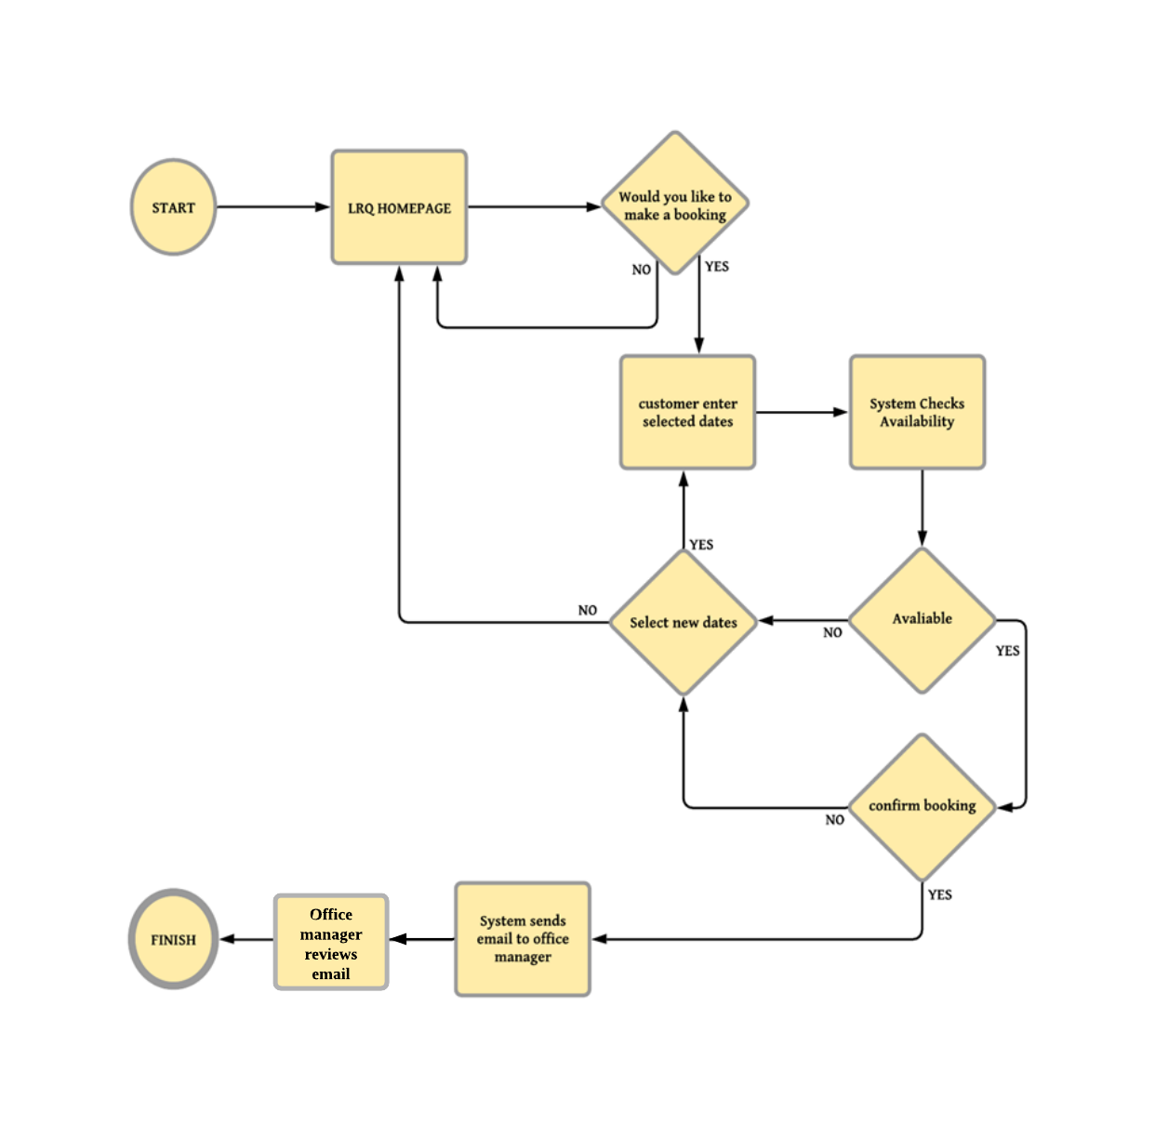

**Cancellation System**

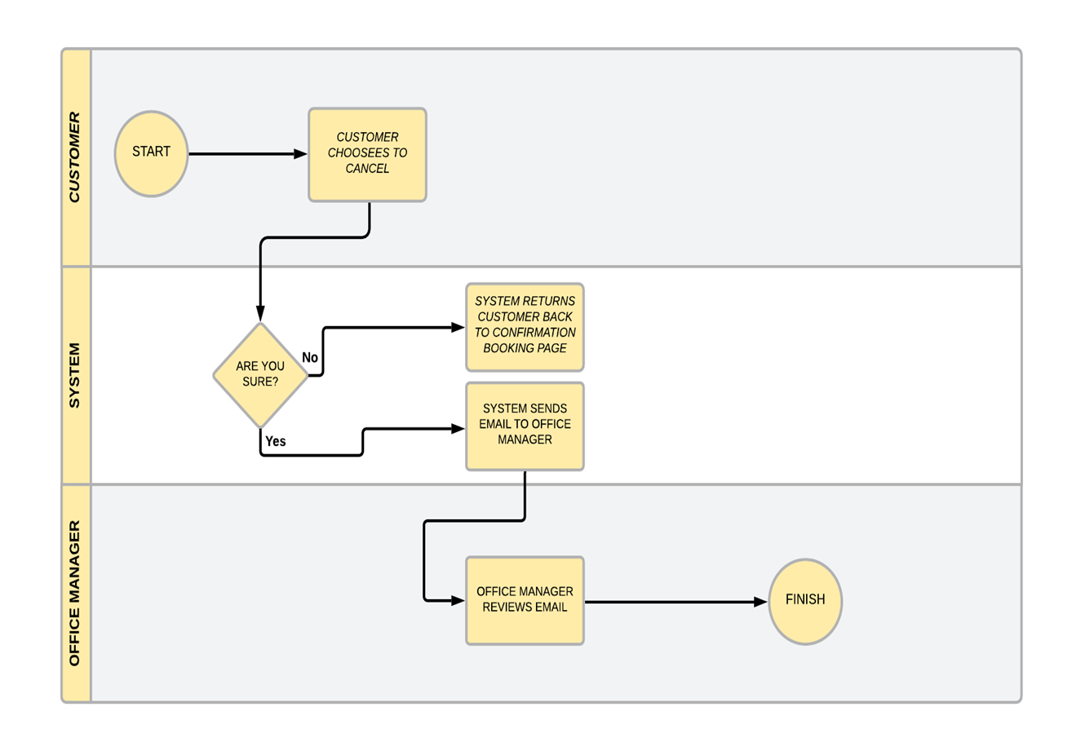

# Terms Of Reference

Case Study (2021, june 01). *INFO 502 Business systems analysis and design*. Retrieved from Assignment 2 soft copies: https://learning.wintec.ac.nz/course/view.php?id=13360&section=5

Sample User Requirements Document (2021, june 01). INFO 502 Business systems analysis and design. Retrieved from Assignment 2 soft copies: https://learning.wintec.ac.nz/course/view.php?id=13360&section=5

Guide To Creating User Requirements Document (2021, june 01). *INFO 502 Business systems analysis and design*. Retrieved from Assignment 2 soft copies: https://learning.wintec.ac.nz/course/view.php?id=13360&section=5

Assignment 2 Marking Guide (2021, june 01). INFO 502 Business systems analysis and design. Retrieved from Assignment 2 soft copies: https://learning.wintec.ac.nz/course/view.php?id=13360&section=5

Lucid (2021, june 01). Lucid Charts. Retrieved from Lucid Charts: https://www.lucidchart.com/pages/

Miller, D. (2021, may 25). *ProProfs*. Retrieved from What are Project Constraints and how to manage them: https://www.proprofs.com/c/project/project-constraints/